**FPT ACADEMY INTERNATIONAL**

**FPT – APTECH COMPUTER EDUCATION**

**Centre Name: ACE-THUDUC-1-FPT**

**Address: 590 Cach Mang Thang 8, 3 District, Ho Chi Minh City, Viet Nam**

**Excellent Coaching**

|  |  |  |
| --- | --- | --- |
| **Supervisor.** | Mr. Nguyen Phat Tai | |
| **Batch.** |  | |
| **Group.** | Group 2 | |
| **Serial No.** | **Enrollment Number** | **Student Name** |
| 1. | Student1470293 | Trần Hương Giang |
| 2. | Student1470293 | Đào Hoàng Hải |
| 3. | Student1470280 | Trần Văn Bằng |
| 4. | Student1429833 | Lê Thị Tuyết Mai |

Otc 16th, 2023

**This is to certify that**

* Ms. Tran Huong Giang
* Ms. Le Thi Tuyet Mai
* Mr. Dao Hoang Hai
* Mr. Tran Van Bang

**Has successfully design & developed**

E-Project: **Excellent Coaching**

**Submitted by: Ms. Tran Huong Giang**

**Date of issue: Oct 16th, 2023**

**Authorized Signature: Ms. Tran Huong Giang**

***TABLE OF CONTENT***

ACKNOWLEDGEMENT4

SYNOSIS4

PROBLEM DEFINITION5

CUSTOMER’S REQUIREMENTS SPECIFICATION6

SCOPE OF THE WORK9

ARCHITECTURE AND DESIGN OF THE SYSTEM10

DIAGRAM OF THE WEBSITE………………………… ……………………………………11

TASK SHEET REVIEW 1……………..………………………………………………………12

SITE MAP………………………………………………………………………………………13

MOCK OF THE WEBSITE……………………………………………………………………14

1. HOME………………………………………………………………………………..14

2. INTRO………………………………………………………………………………..15

3. CLASS……………………………………………………………………………….16

4. ABOUT US…………………………………………………………………………..18

5. CONTACT…………………………………………………………………………...21

6. TOS…………………………………………………………………………………..22

7. PRIVACY…………………………………………………………………………….23

TASK SHEET REVIEW 2……………………………………………………………………..24

WEBSITE DESCRIPTION……………………………………………………………………26

1. HOME PAGE………………………………………………………………………..26

2. INTRO PAGE………………………………………………………………………..28

3. CLASSES PAGE……………………………………………………………………31

4. COURSE PAGE…………………………………………………………………….33

5. ABOUT US PAGE…………………………………………………………………..35

6. GALLERY PAGE……………………………………………………………………37

7. BLOG PAGE………………………………………………………………………...39

8. CONTACT PAGE…………………………………………………………………...42

9. TOS PAGE…………………………………………………………………………..44

10. PRIVACY PAGE…………………………………………………………………..46

TASK SHEET REVIEW 3……………………………………………………………………..48

***ACKNOWLEGMENT***

On behalf of all the members of group 2, I would like to thank you all for the hard works, supports to make this eProject complete successfully. Especially, Mr. Nguyen Phat Tai, our teacher, he helped us a lot from the day that we started to study at FPT Aptech. With this eProject, he has guided us with his enthusiasm and rigorous, because of his guiding, we would be able to finish this project. Besides, I want to thank all the team member of group 2, each of the team members has been working continuously in 4 weeks in order to complete this project. Last but not least, we would like to say thank you to our family for always supporting us, creating the best conditions for us to focus on the project, and putting faith in the dreams we pursue.

***SYNOSIS***

The evolution of our Excellent Coaching gym company has been nothing short of remarkable. From humble beginnings, we have grown into a thriving fitness establishment that is known for its excellence in the industry.

Our journey started with a vision to create a space where individuals could pursue their fitness goals and lead healthier lives. Over the years, we have expanded our facilities, invested in cutting-edge equipment, and assembled a team of passionate trainers and staff. Through our unwavering commitment to providing top-notch services and personalized experiences, we have become a trusted name in the fitness community. We continue to embrace innovation, adapt to changing trends, and exceed the expectations of our valued members.

***PROBLEM DEFINITION***

The Web site is to be created based on the following requirements.

1) The Home Page should have suitable logo, and decent colour combination.

2) Information should be neatly placed at suitable location.

3) Various pages having information about different courses/subjects taught at the classes, Faculty/Teachers complete information and previous year’s success stories should be listed.

4) The site should display a menu which will contain the options for brief introduction about the above mentioned information, location/address of the coaching classes and any other information if required.

5) The information should be categorized according to different subjects like if a User wants to see details of ‘Commerce’ then he click on a Link/button/menu etc and he will see details of course structure of commerce. Similarly for ‘Mathematic’, ‘Languages’ and other subjects.

6) When a user selects any course stream, complete list of subjects for that course stream will be displayed.

7) Details of the courses should be displayed on the Web Page along with the title and it should be stored in Individual Word documents which can be downloaded or viewed by the User who wishes to see the same.

8) Price List for all courses should be available for download.

9) There should be a “Contact Us” page which will have the Address of the Coaching Classes and the mail address which when clicked will invoke the local mail client from where they can send an email. Address of the Company should be displayed using GeoLocation API (eg. GoogleMaps).

***CUSTOMER’S REQUIREMENT SPECIFICATION (CRF)***

**Client: Excellent Coaching.**

**Business / Project Objective**

* The Objective of this program is to give a sample project to work on real life projects. These applications help you build a larger more robust application.
* The objective is not to teach you JavaScript (React Framework) but to provide you with a real life scenario and help you create basic applications using the tools.
* You can revise the chapters before you start with the project.
* This project is meant for students who have completed the module of ***HTML5***. These programs should be done in the Lab sessions with assistance of the faculty if required.
* It is very essential that a student has a clear understanding of the subject. Students should go through the project and solve the assignments as per requirements given.
* Kindly get back to [eprojects@aptech.ac.in](mailto:eprojects@aptech.ac.in) in case of any doubts regarding the application or its objectives.

**Input to the system:**

- Class system information

- Includes class and coach information

**Output from the system:**

- Menu will categorize all the functions of the website.

- Displays list of available categories wisely.

- Perform a search based on a specific: brand, course.

- Perform a search based on a specific event type

- The website will display a menu with various sections listed in it.

- Show gym locations in Contact Us page.

- In addition to the above requirements, the website must have an interface according to industry standards.

**Expected delivery date:** October 16th, 2023

**List of deliverables:**

* Document Word
* User Guide
* Source Code
* Video Clip

**Hardware/Software Requirements:**

1. **For Developer**

Hardware

* A minimum computer system that will help you access all the tools in the courses is a Pentium 166 or better
* 64 Megabytes of RAM or better

Software

Technologies to be used:

* Frontend: HTML5, CSS3 (SCSS), Bootstrap, JavaScript, ReactJS.
* Data Store: JSON files or TXT files

1. **For web user**

Hardware

* Intel Pentium 4 processor or higher
* 512 Megabytes of RAM of higher

Software

* Operating Portal: Windows
* Browsers: Edge, Chrome, Mozilla Firefox, Safari

***SCOPE OF THE WORK (IN BRIEF)***

After a long and detailed discussion, our group has decided to create a website contain the following webpages:

1. ***Home:*** Display most important information through slider, banner, brief text to help customers understand the basics of the service that Excellent Coaching provides.
2. ***Intro:*** Outline the benefits that our services bring..
3. ***Class:*** Customers will find out information about the class/course they want to join..
4. ***About Us:*** A little introduction about the formation and development process of our company (as well as the big milestones we have achieved in history).

* ***Blog:*** Update outstanding news that customers are interested in about health care, advice, and celebrities. etc.
* ***Gallery:*** Memories of students who have gone through the journey with us.

1. ***Contact Us:*** Displays information about company: founder, CEO, phone number, email, address.
2. ***Terms Of Service:*** Terms of service that customers need to know to register to participate and stay with us for a long time.
3. ***Privacy Policy:*** Explains how we use customers' personal data..

***ARCHITECTURE AND DESIGN OF THE SYSTEM***

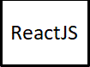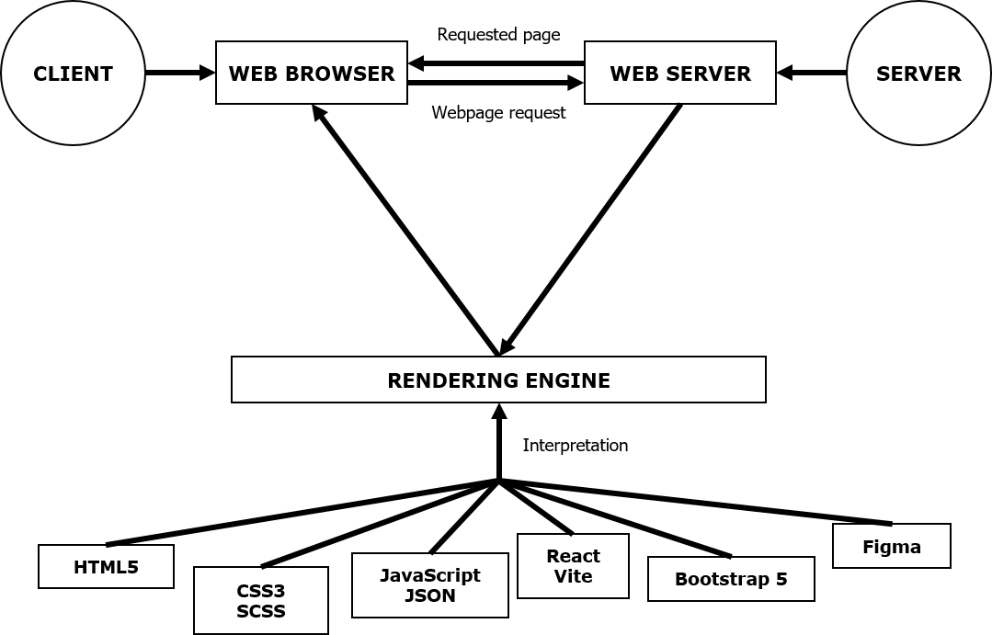

***DIAGRAM OF THE WEBSITE***

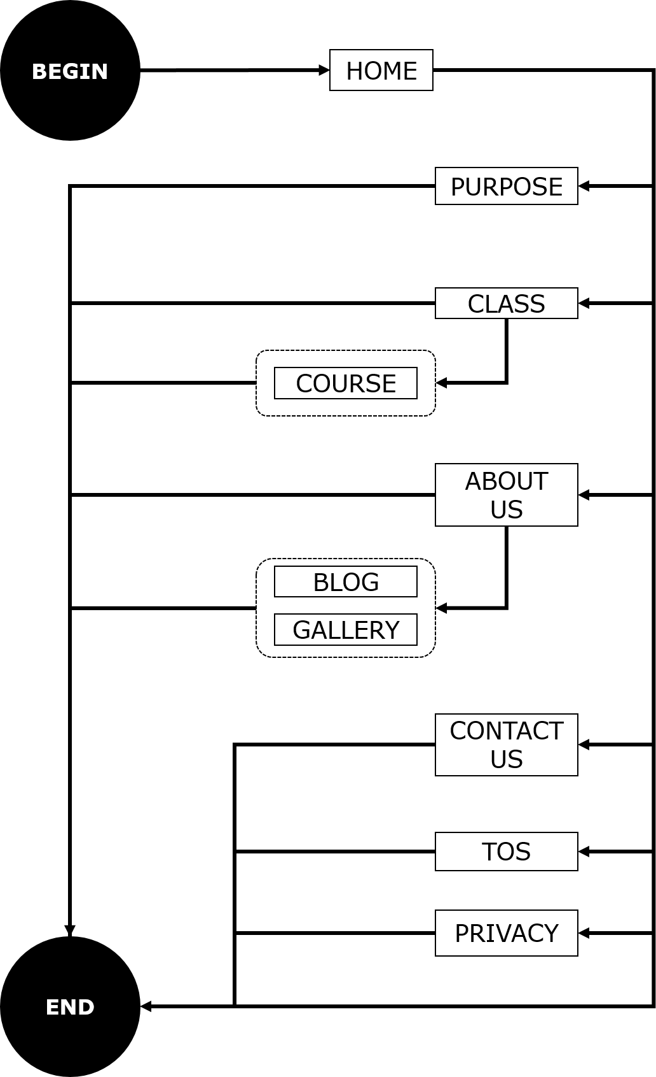

***TASK SHEET REVIEW 1***

|  |  |  |  |  |  |  |  |
| --- | --- | --- | --- | --- | --- | --- | --- |
| **Project Ref. No.:**  **eP/Advertisement Portal Management System/01** | | **Project Title:** | **Activity Plan Prepared By:** | **Date of Preparation of Activity Plan:** | | | |
| **Sr.**  **No.** | **Task** | **Actual**  **Start Date** | **Actual Days** | **Team**  **Mate Names** | **Status** |
| 1 | Problem Statement | Excellent  Coaching | Giang | 15-Sep-2023 | 1 | Giang, Hải, Bằng | Completed |
| 2 | Analysis of requirements about the website | 15-Sep-2023 | 1 | Giang, Hải, Bằng | Completed |
| 3 | The scope of the work (in brief) | 15-Sep-2023 | 1 | Giang, Hải, Bằng | Completed |
| 4 | Architecture and design of the system | 15-Sep-2023 | 1 | Giang, Hải, Bằng | Completed |
| 5 | Diagram of the website | 15-Sep-2023 | 1 | Giang, Hải, Bằng | Completed |
| 6 | Home Page | 17-Sep-2023 | 1 | Giang, Hải, Bằng | Completed |
| 7 | JSON Files | 17-Sep-2023 | 1 | Giang, Hải, Bằng | Completed |
| 8 | Task Sheet | 17-Sep-2023 | 1 | Giang, Hải, Bằng | Completed |

|  |  |
| --- | --- |
| **Date: 16 – Otc – 2023** | |
| Signature of Instructor:  **Mr. Nguyen Phat Tai** | Signature of Team Leader:  **Ms.Tran Hương Giang** |

***SITE MAP***

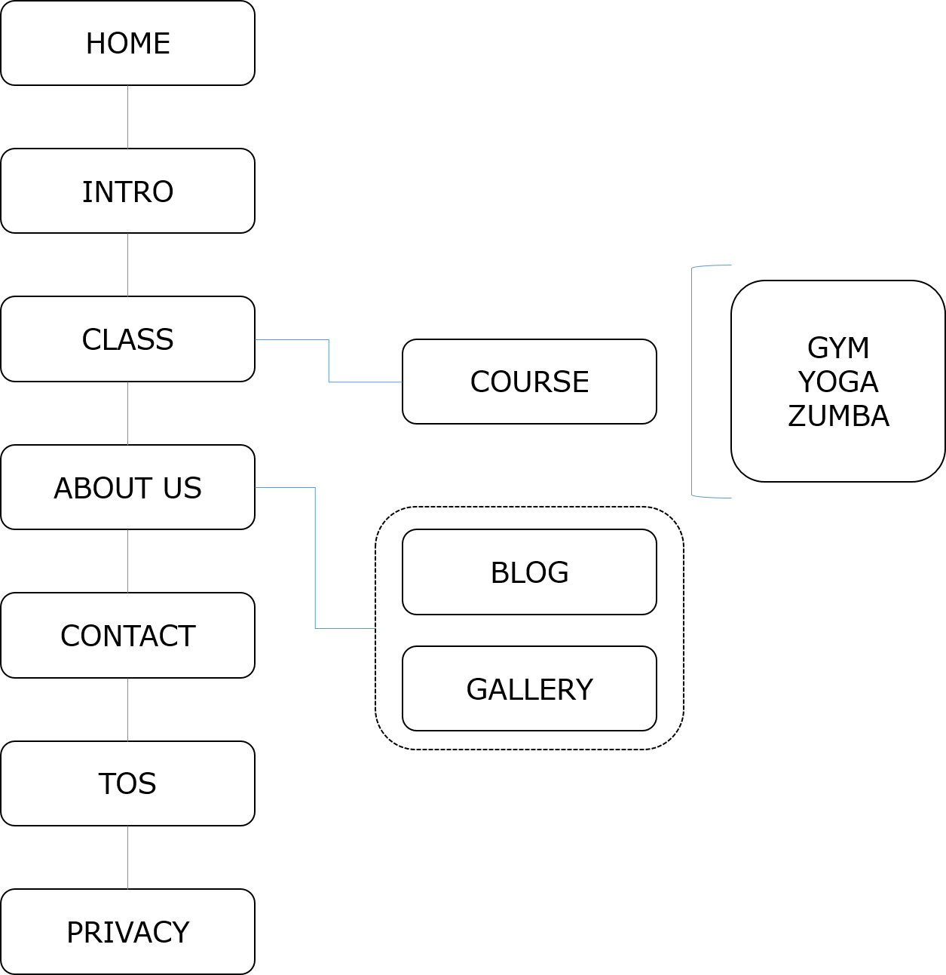

***MOCK OF THE WEBSITE***

***1. HOME***

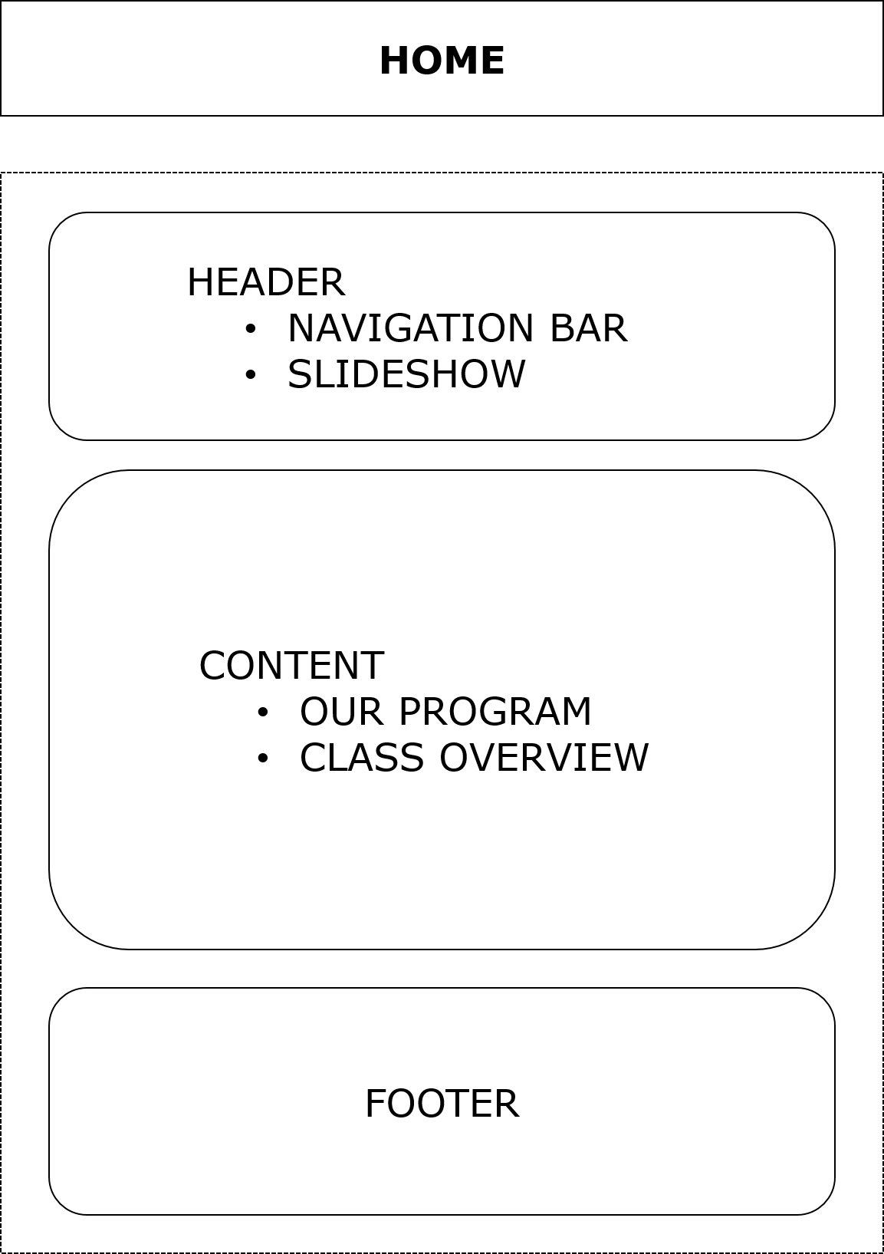

***2. INTRO***

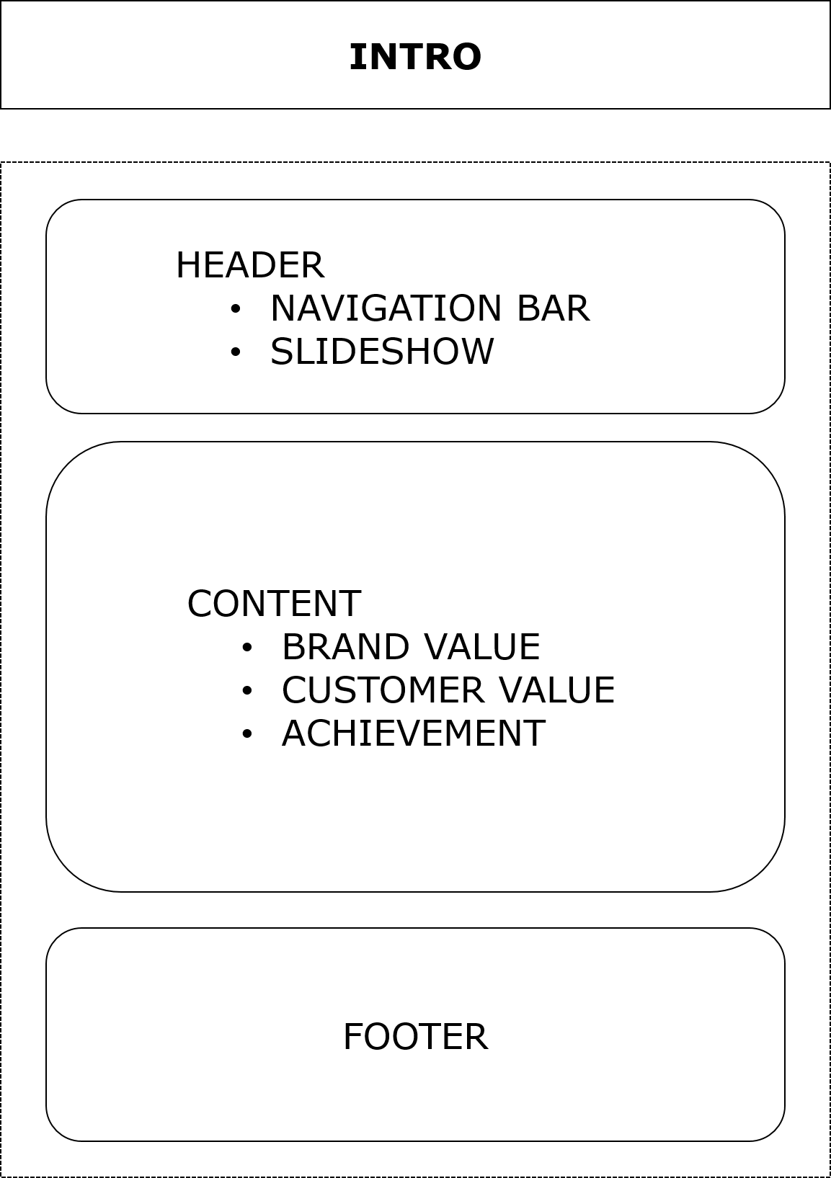

***3. CLASS***

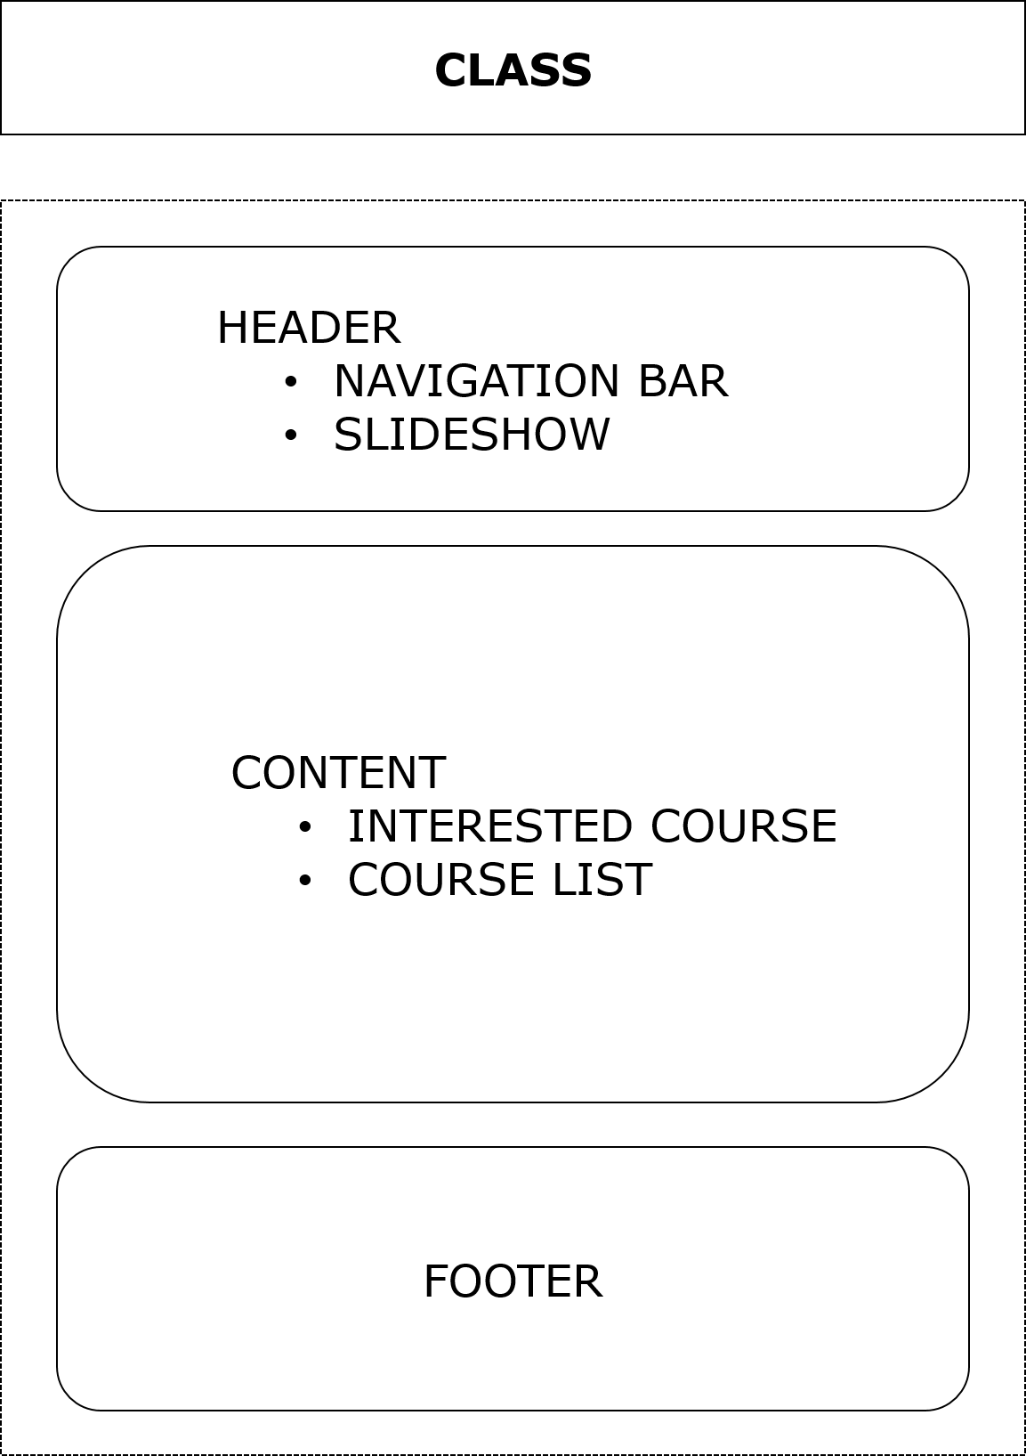

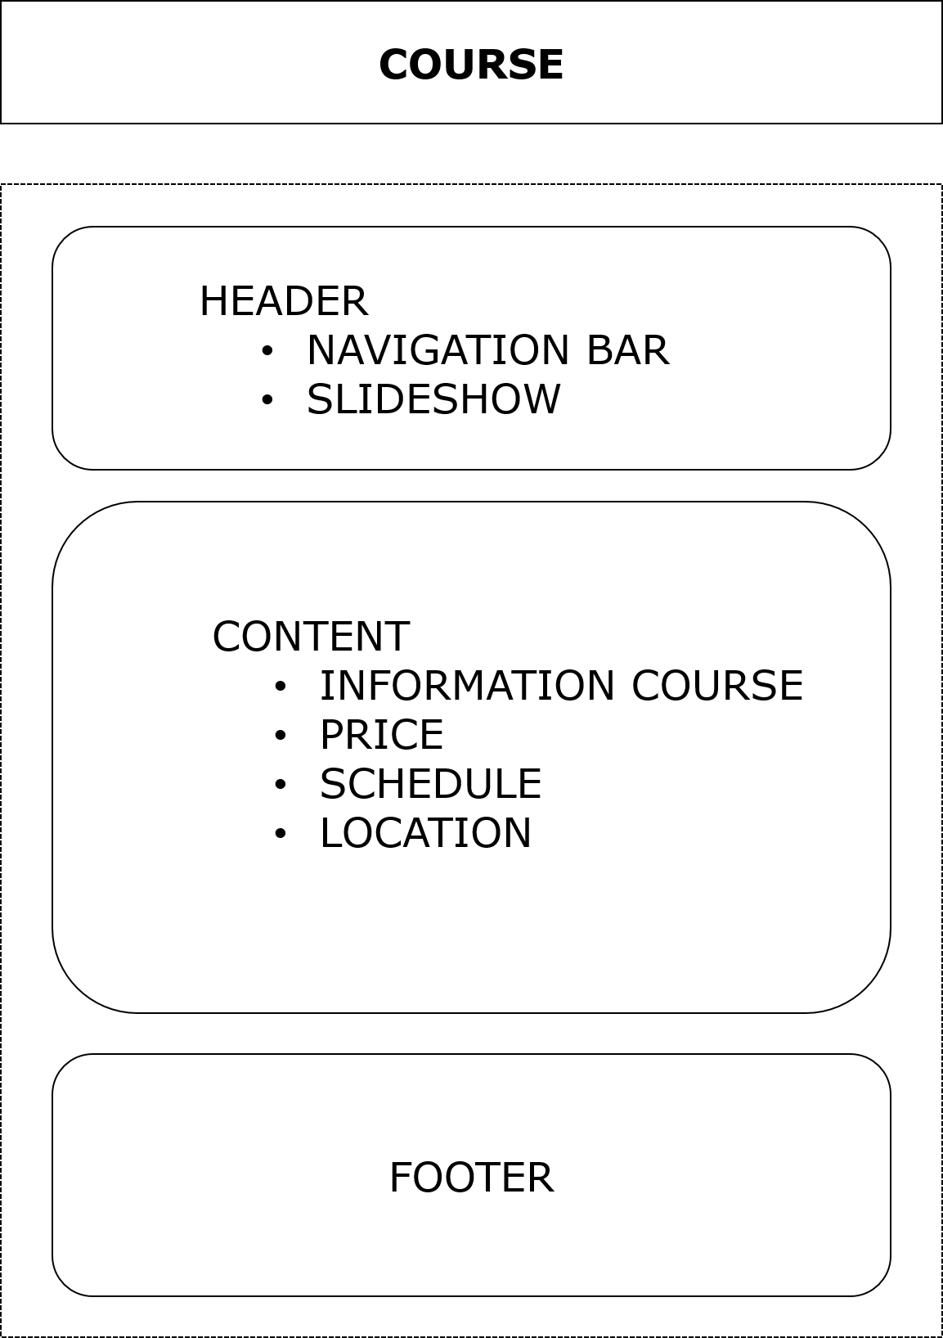

***4. ABOUT US***

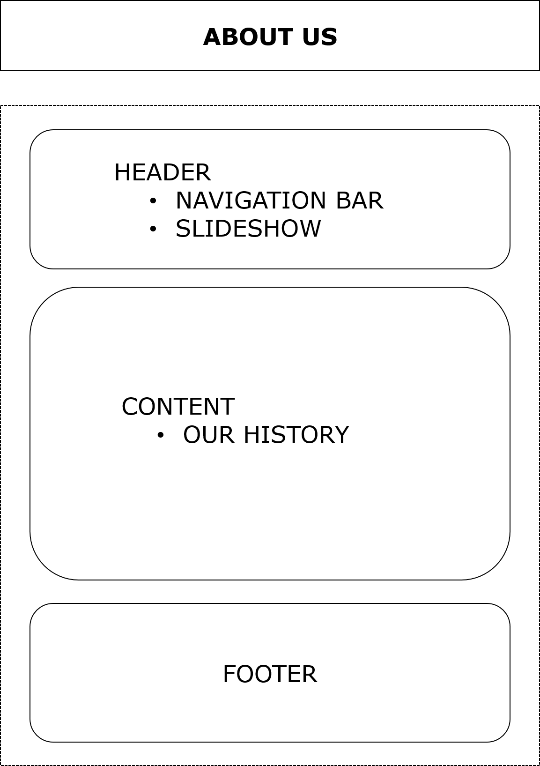

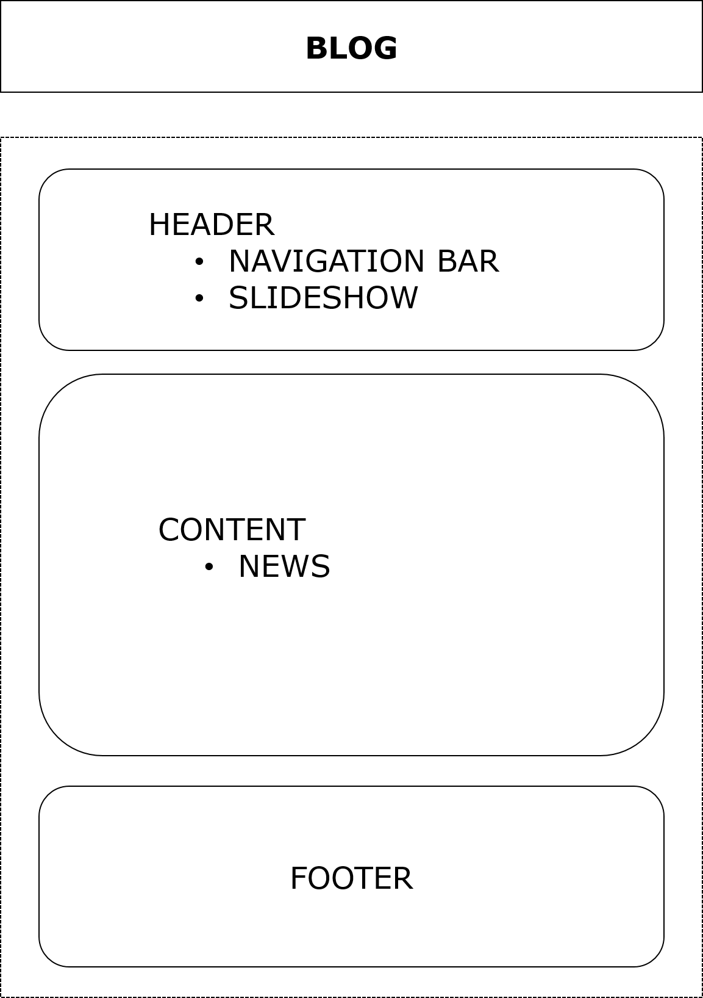

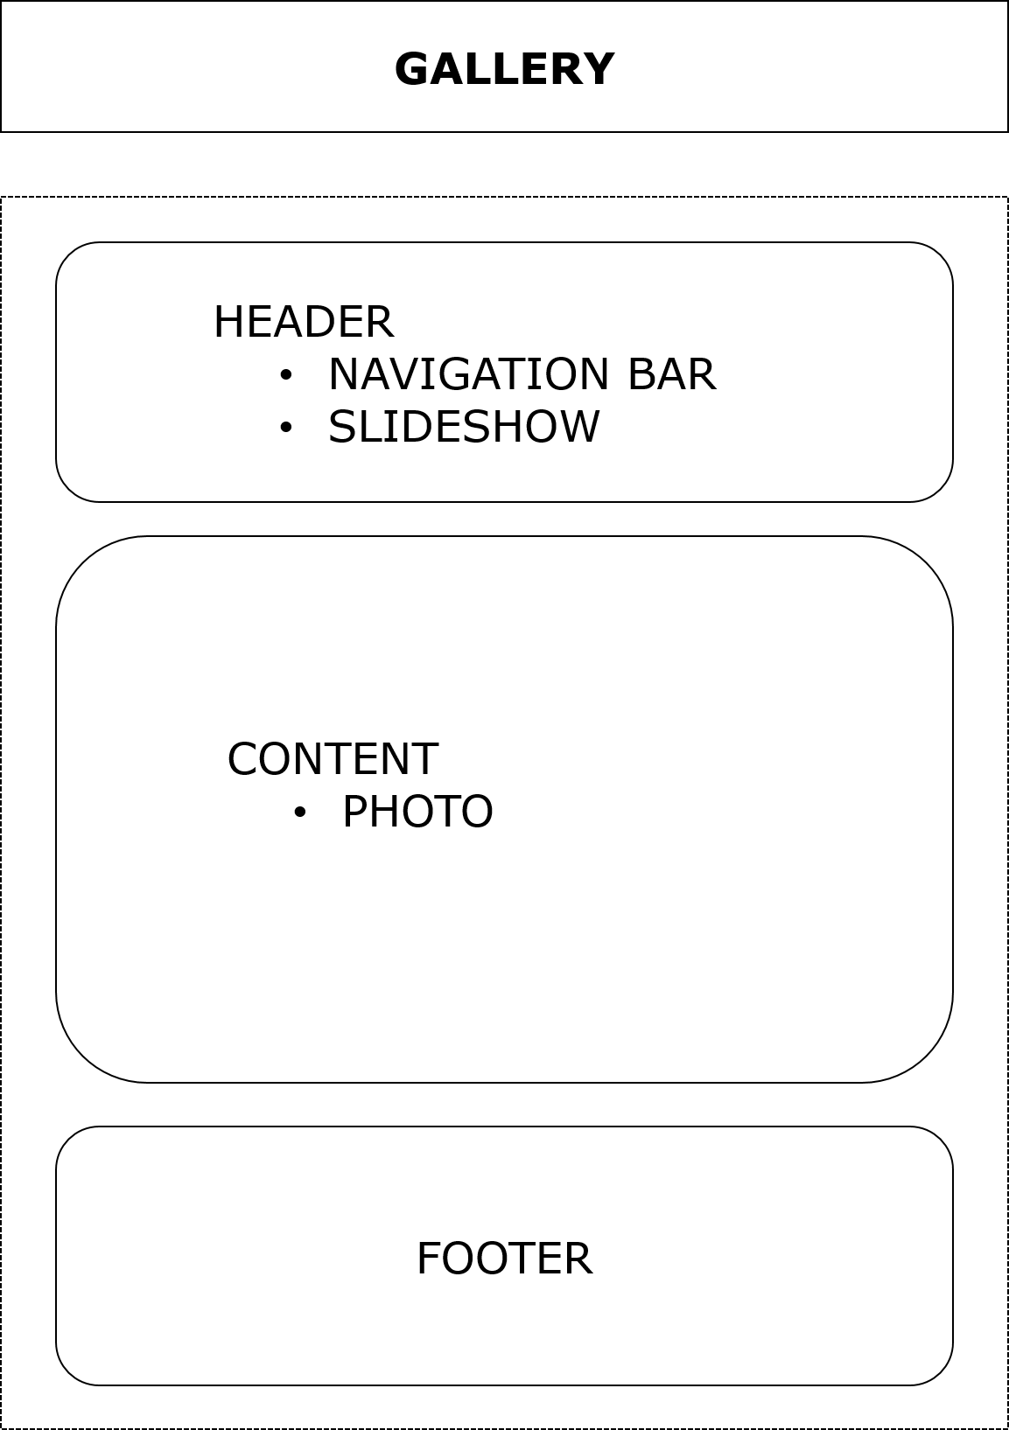

***5. CONTACT***

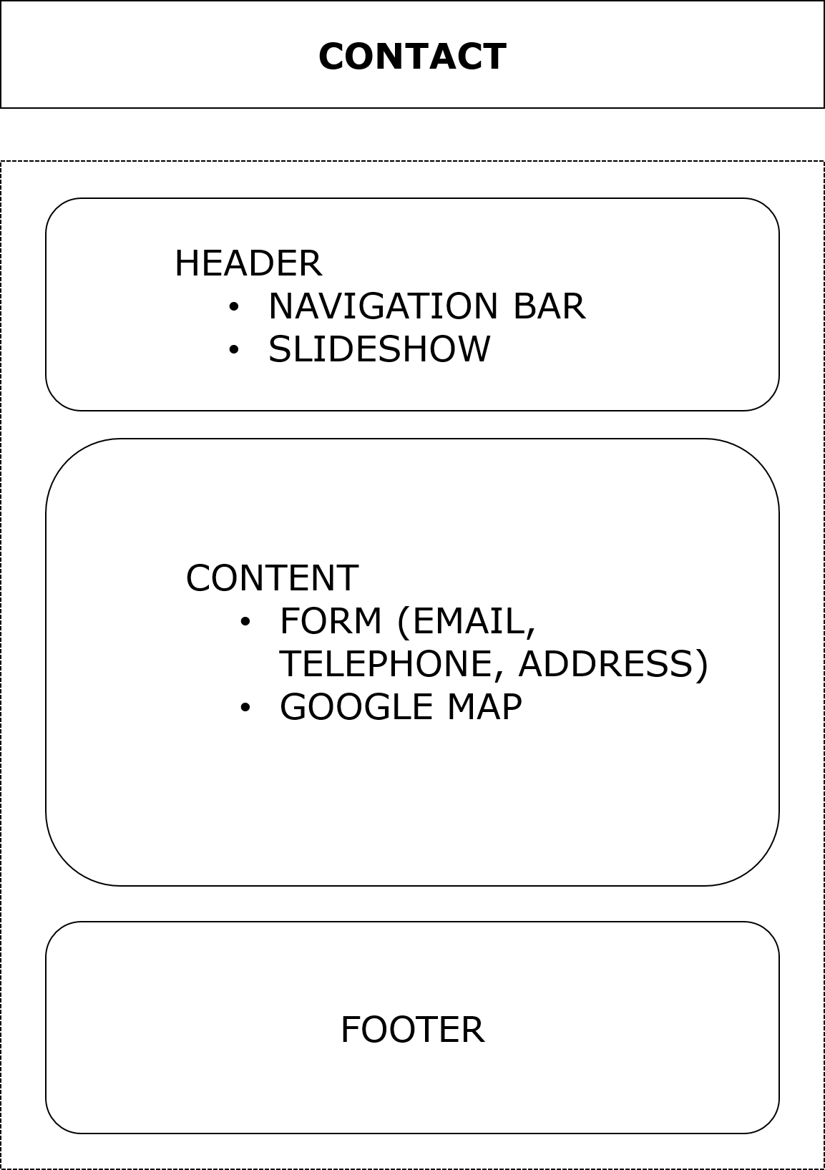

***6. TOS***

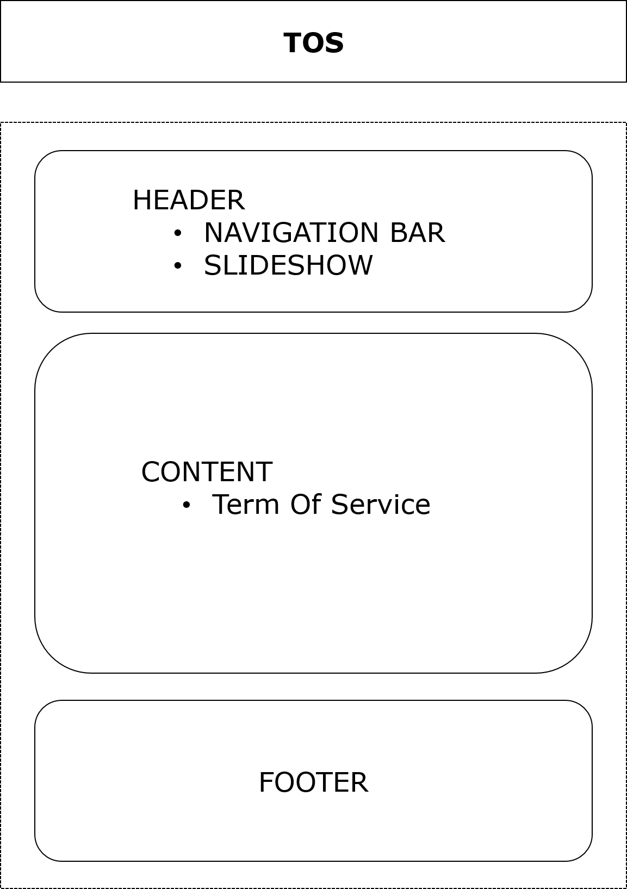

***7. PRIVACY***

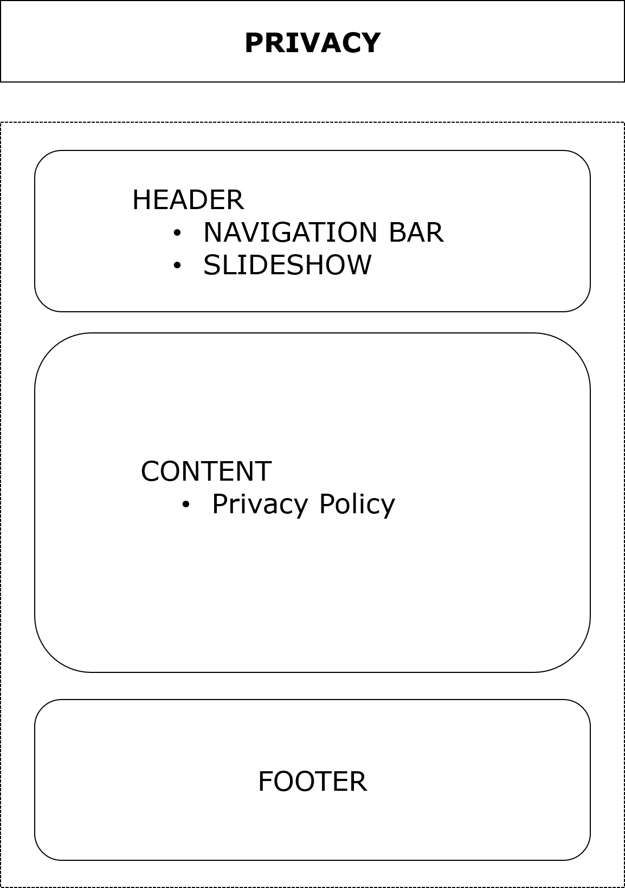

***TASK SHEET REVIEW 2***

|  |  |  |  |  |  |  |  |
| --- | --- | --- | --- | --- | --- | --- | --- |
| **Project Ref. No.:**  **eP/Advertisement Portal Management System/01** | | **Project Title:** | **Activity Plan Prepared By:** | **Date of Preparation of Activity Plan:** | | | |
| **Sr.**  **No.** | **Task** | **Actual**  **Start Date** | **Actual Days** | **Team**  **Mate Names** | **Status** |
| 1 | Created a site map | Excellent  Coaching | Giang | 29-Sep-2023 | 1 | Giang, Hải, Bằng | Completed |
| 2 | Made mock of the website | 29-Sep-2023 | 1 | Giang, Hải, Bằng | Completed |
| 3 | Complete docx and pdf files for download | 29-Sep-2023 | 1 | Giang, Hải, Bằng | Completed |
| 4 | Divide each component for each page | 29-Sep-2023 | 1 | Giang, Hải, Bằng | Completed |
| 5 | Read & Update JSON Files | 29-Sep-2023 | 1 | Giang, Hải, Bằng | Completed |
| 6 | Debug | 29-Sep-2023 | 1 | Giang, Hải, Bằng | Completed |

|  |  |
| --- | --- |
| **Date: 27 – Sep – 2023** | |
| Signature of Instructor:  **Mr. Nguyen Phat Tai** | Signature of Team Leader:  **Ms.Tran Hương Giang** |

***WEBSITE DESCRIPTION***

***1. Home Page: Briefly describe information about the teaching program and the results achieved by students.***

* ***Training program information.***
* ***Result.***

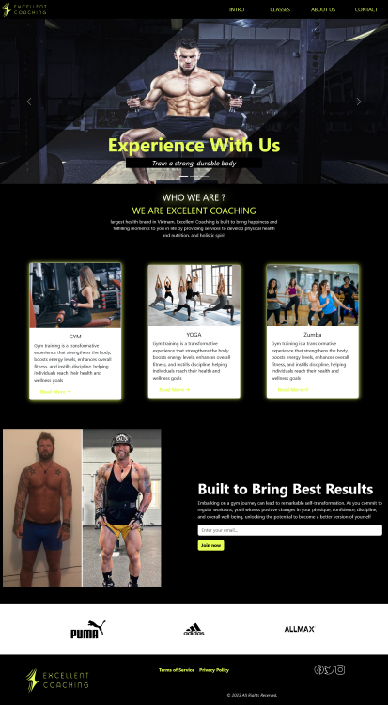

***Source:***

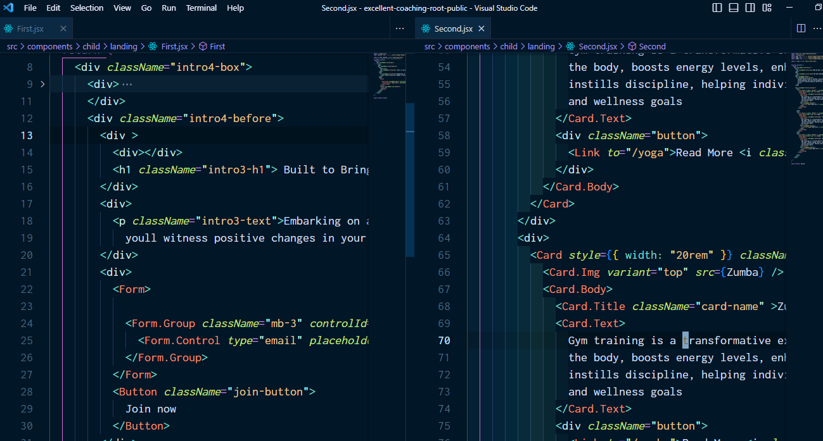

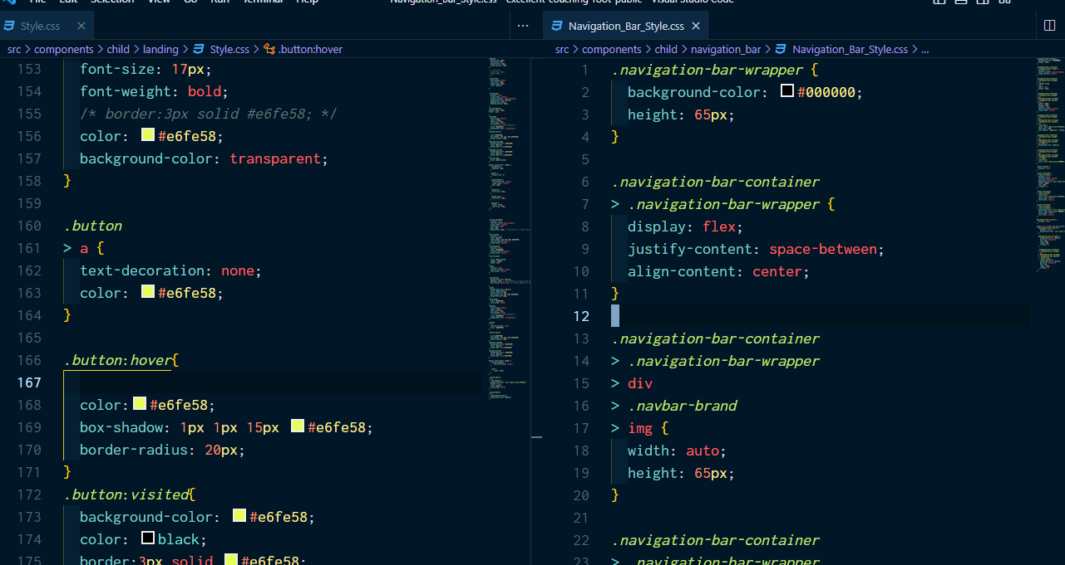

***2. Intro Page: Brief introduction about our goals and potential values***

* ***Our Goal***
* ***Value***

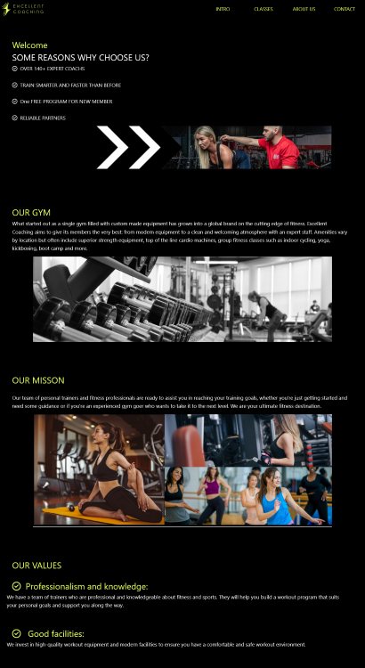

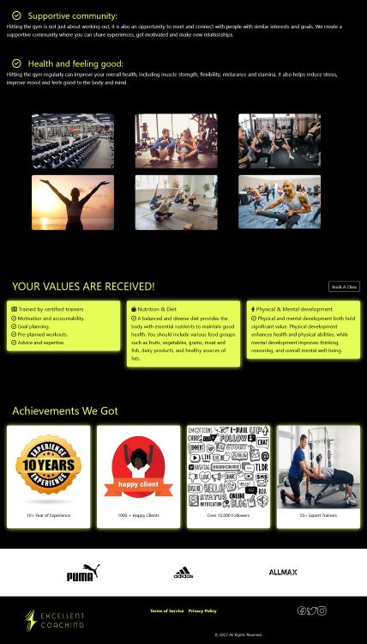

***Source:***

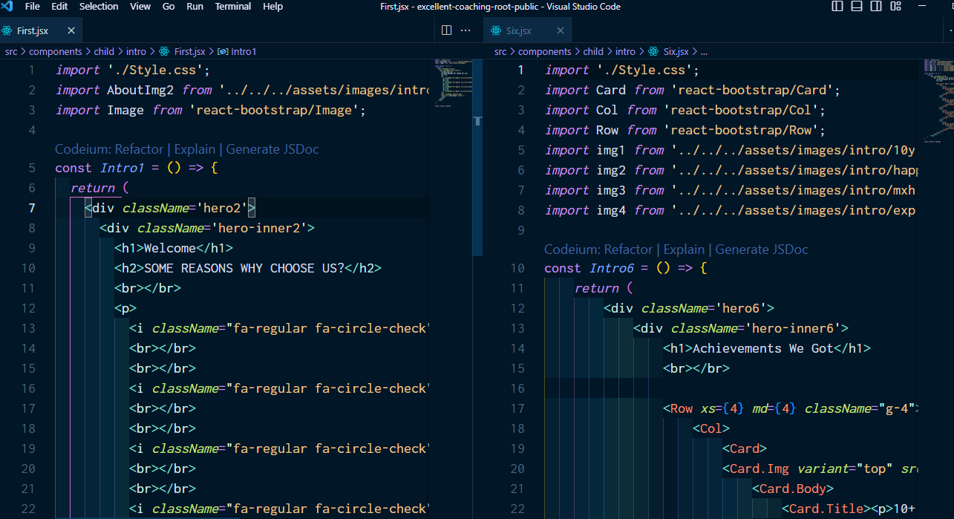

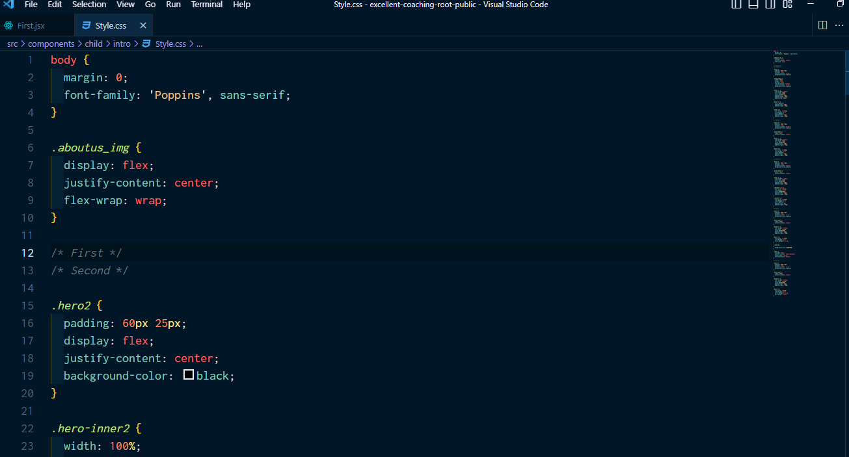

***3. Classes Page: The classes that are of most interest are chosen by students***

* ***Interested Classes***

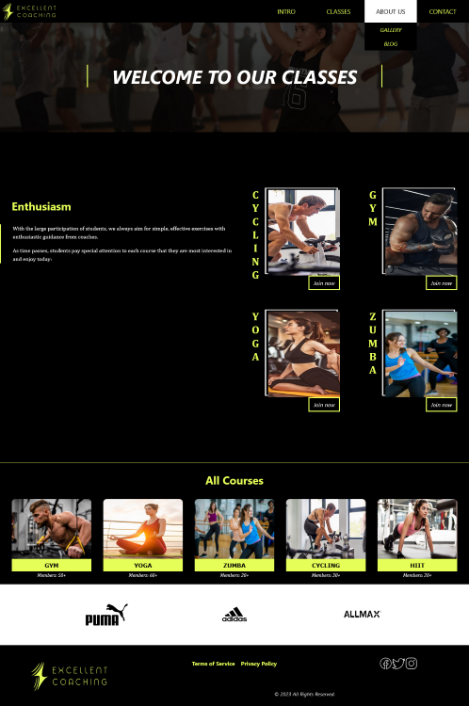

***Source:***

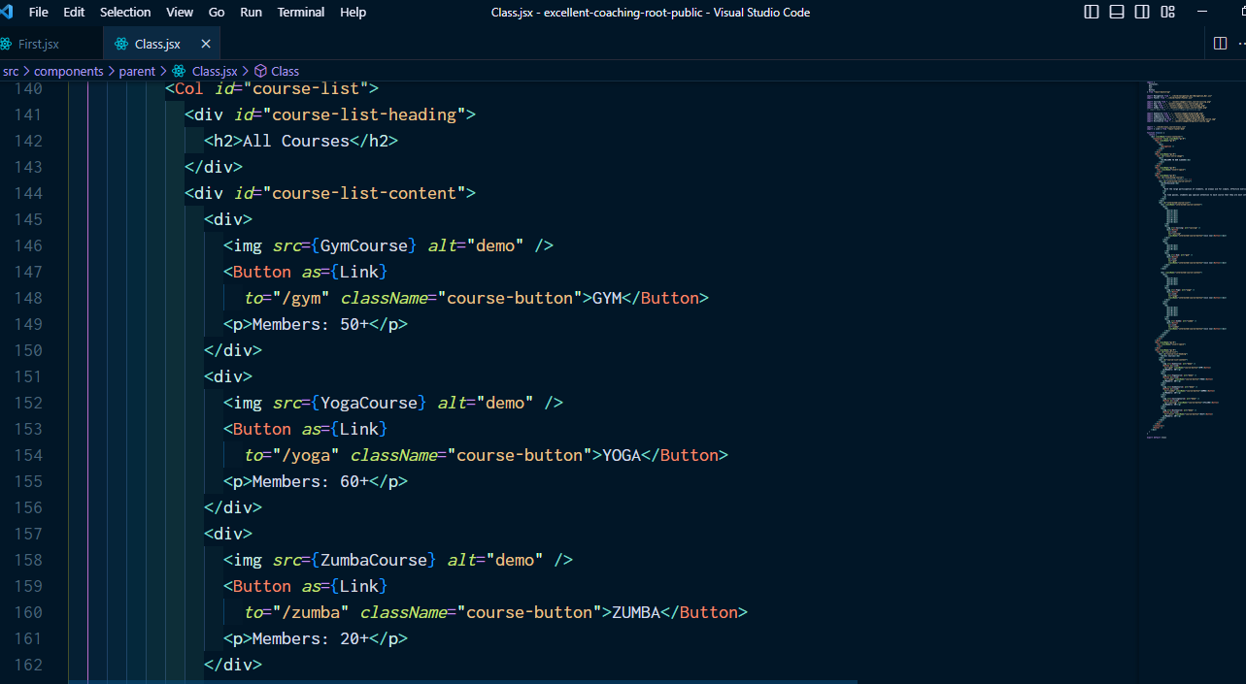

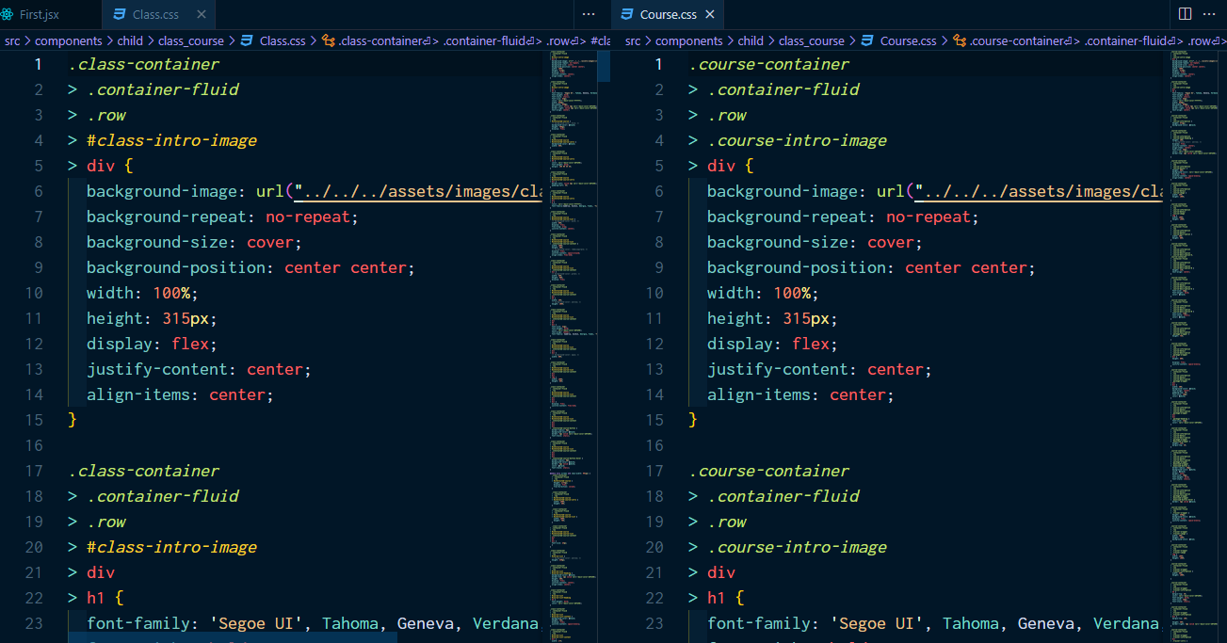

***4. Course Page: Outstanding features of each course, some information about prices, training schedules and coaches***

* ***Information Course (Package, Price, Workout Schedule)***
* ***Information Coaching (Achievements)***

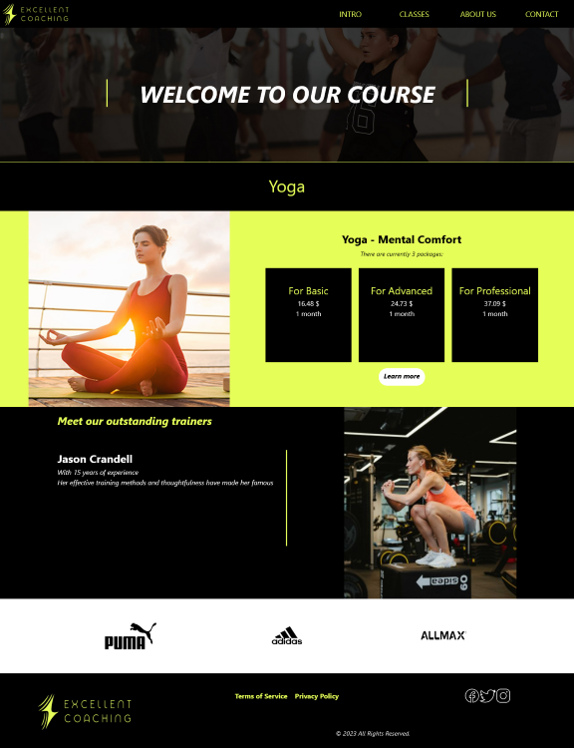

***Source:***

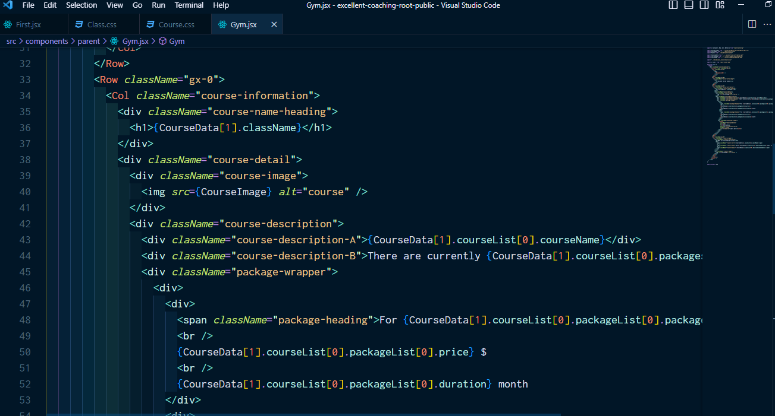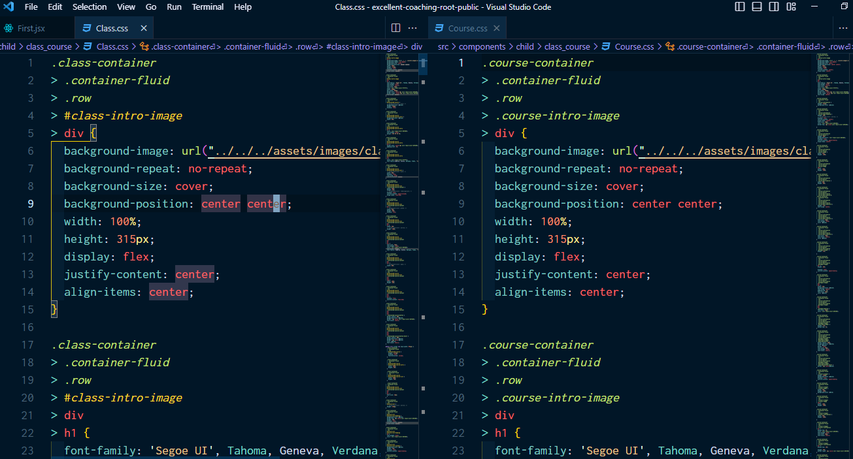

***5. About Us Page: Some of the successes we have achieved***

* ***Timeline***
* ***Event***

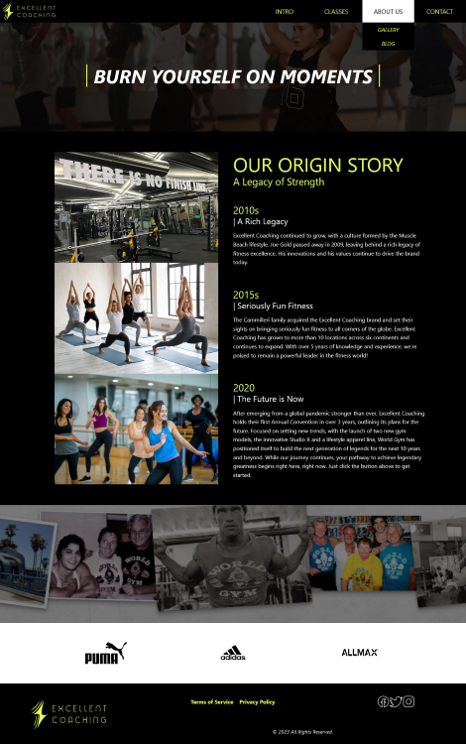

***Source:***

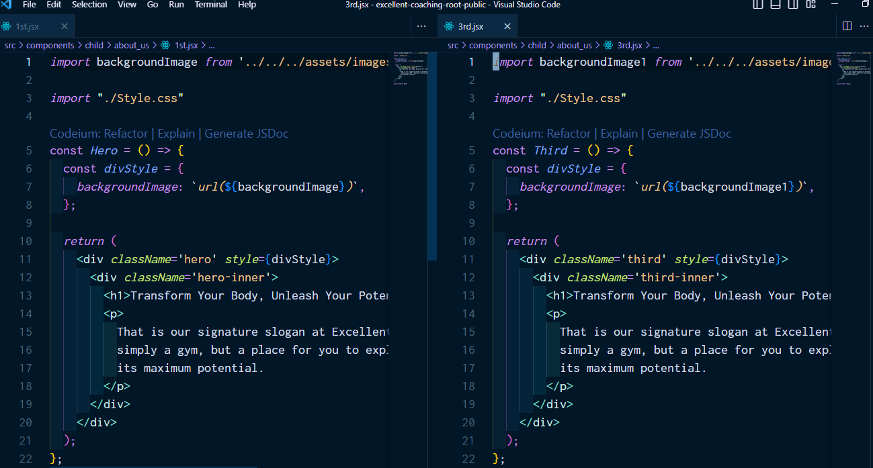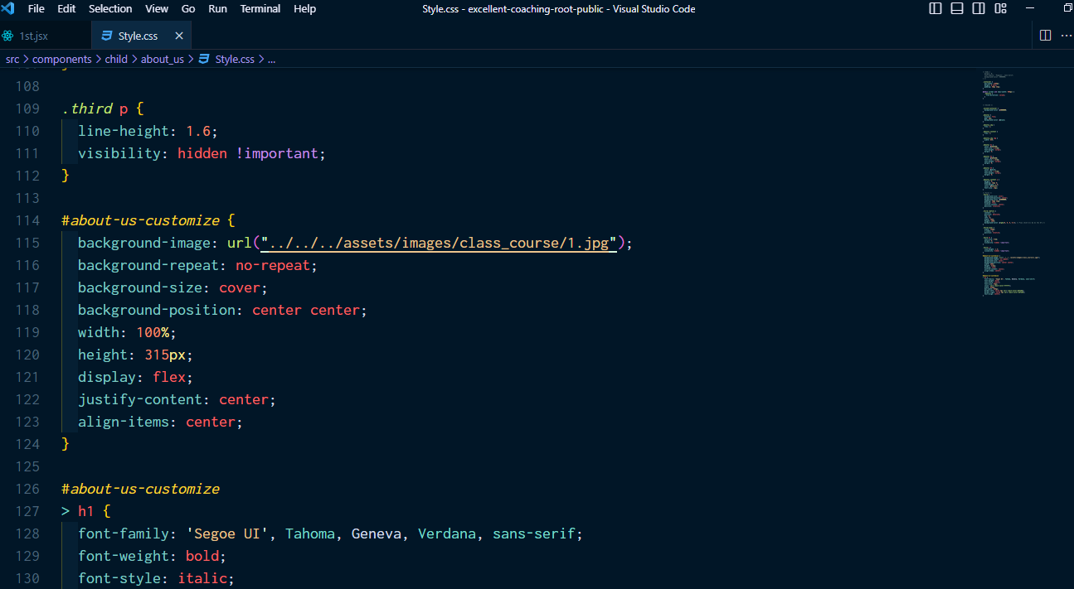

***6. Gallery Page: Some commemorative photos***

* ***Photos***

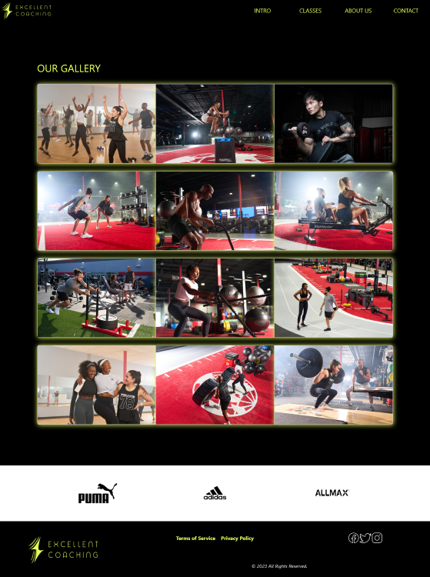

***Source:***

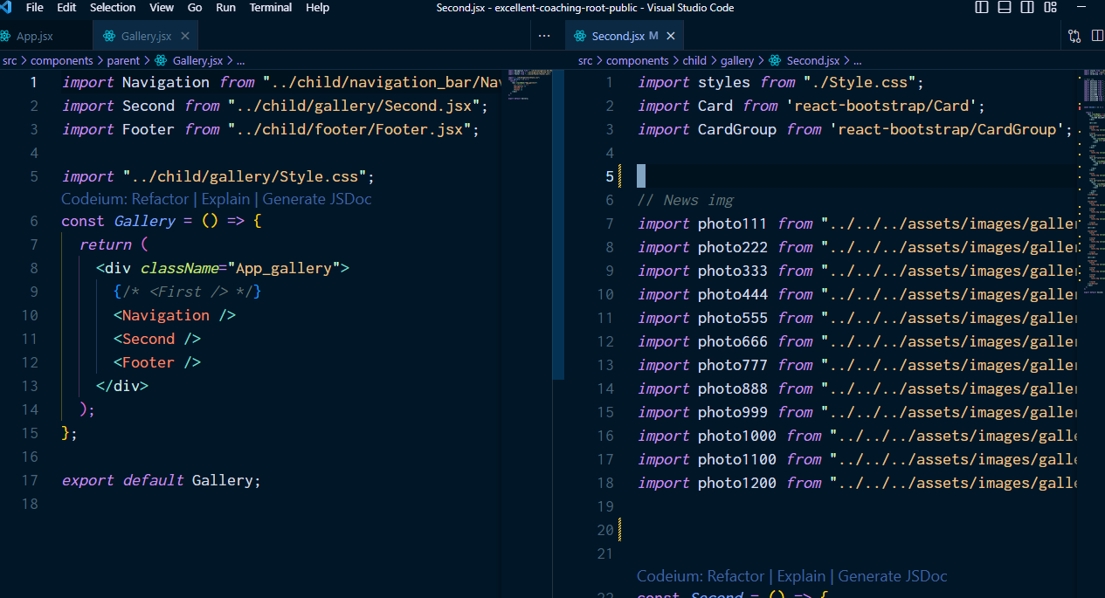

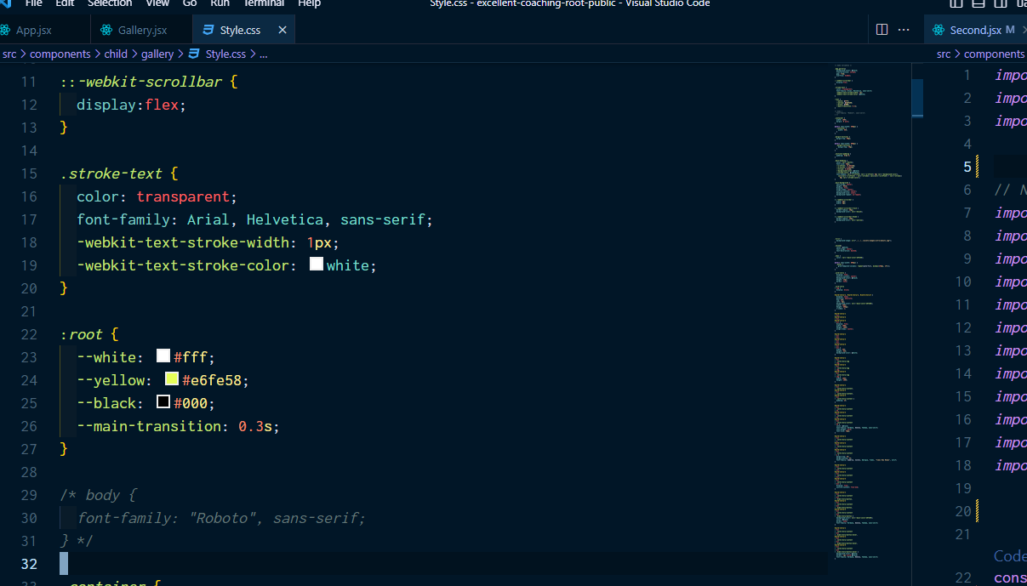

***7. Blog Page: Hot news and articles are updated that make you interested***

* ***Articles***
* ***News***

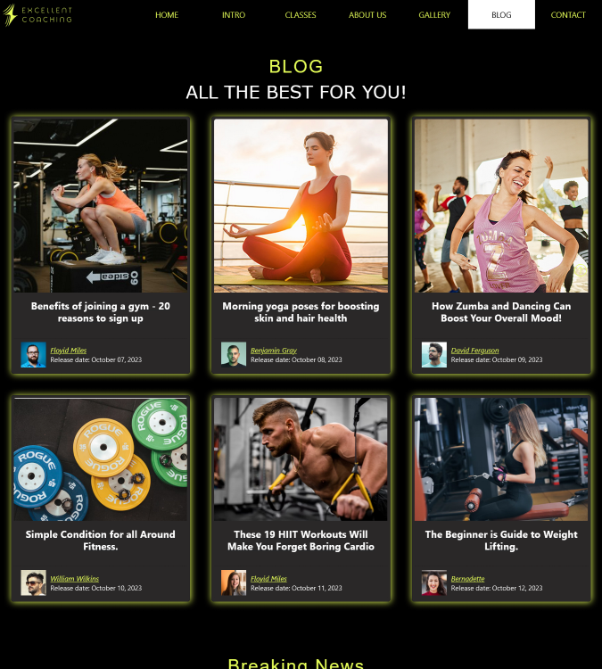

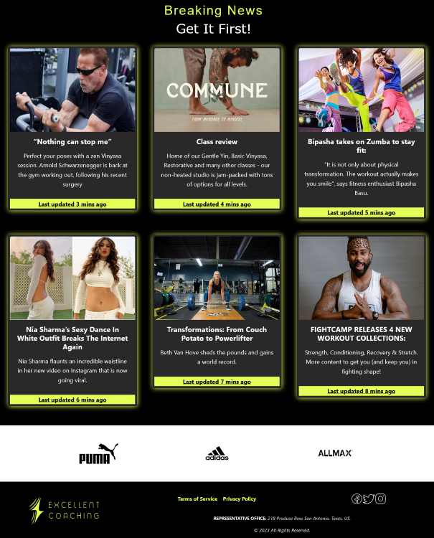

***Source:***

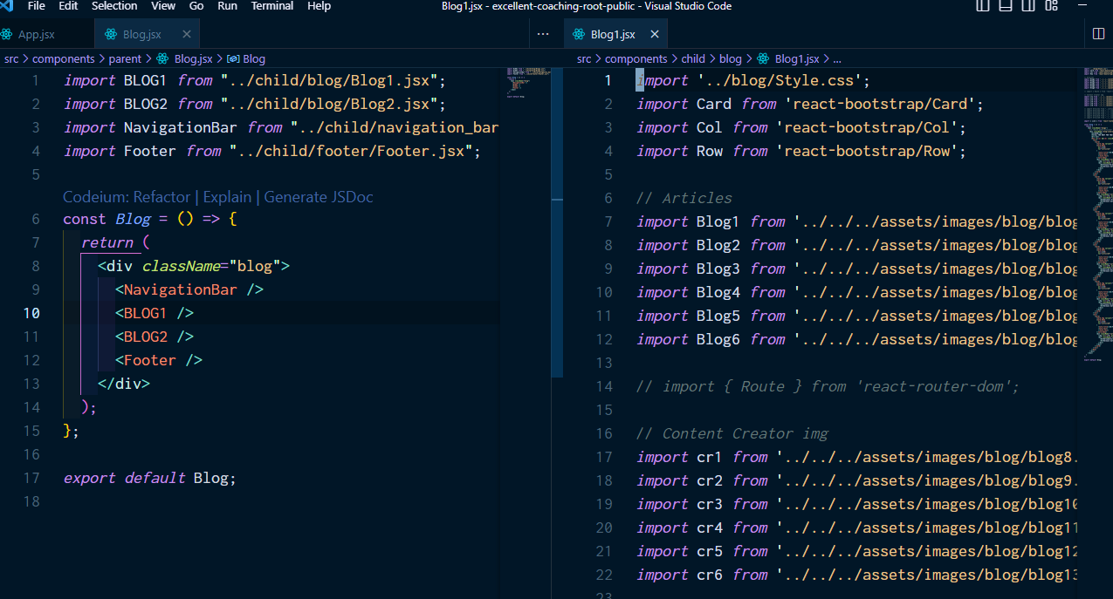

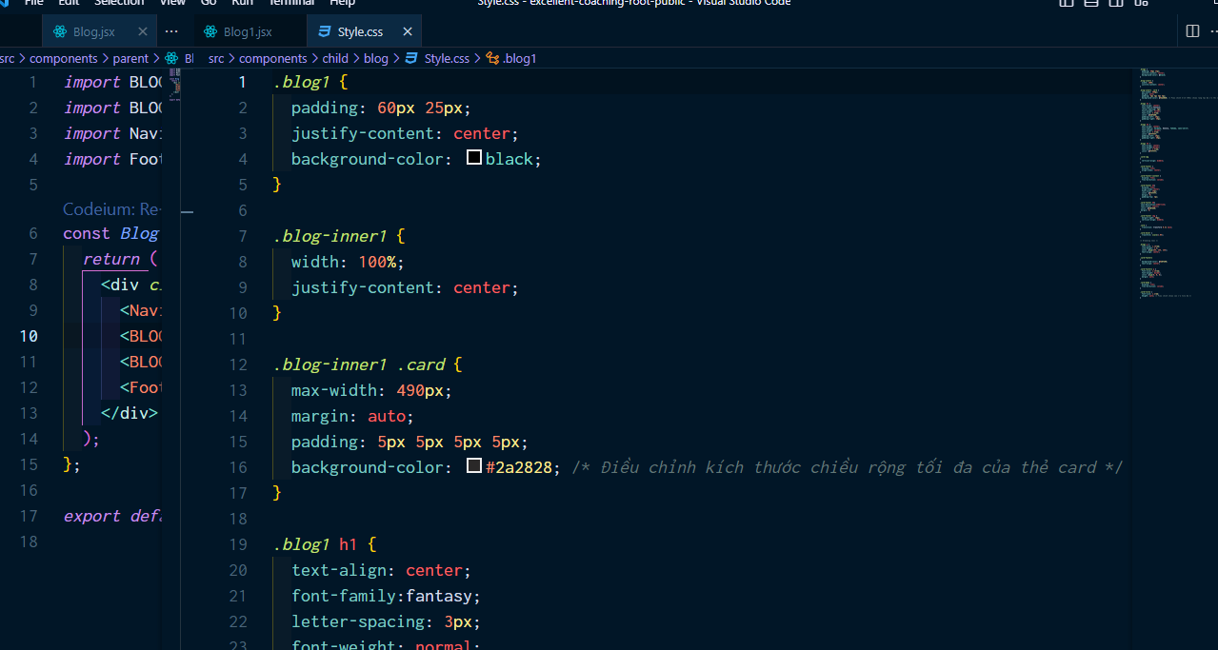

***8. Contact Page: When you have any questions, please contact us***

* ***Contact Form***
* ***Map***

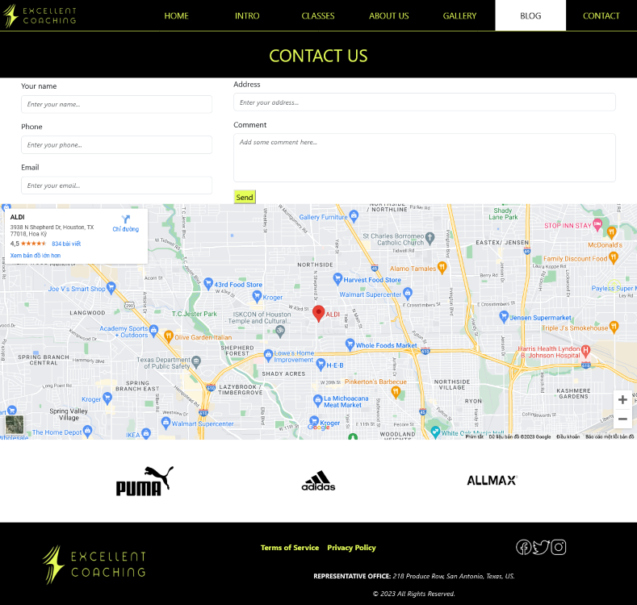

***Source:***

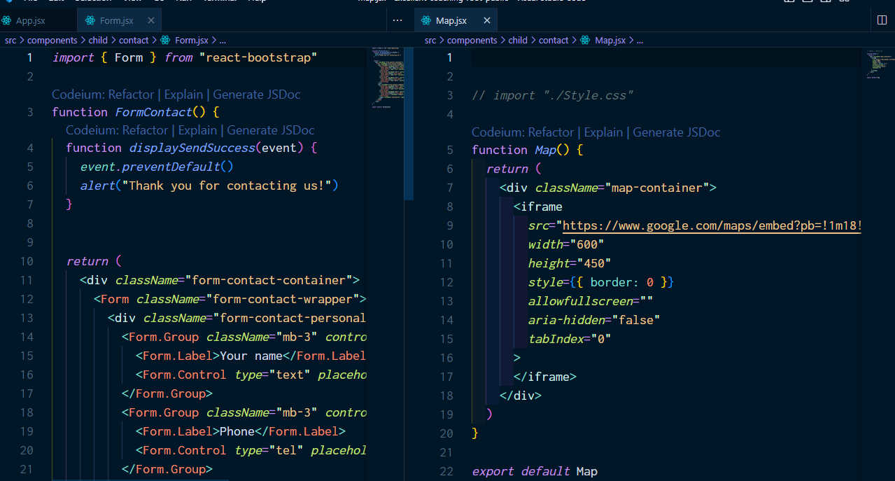

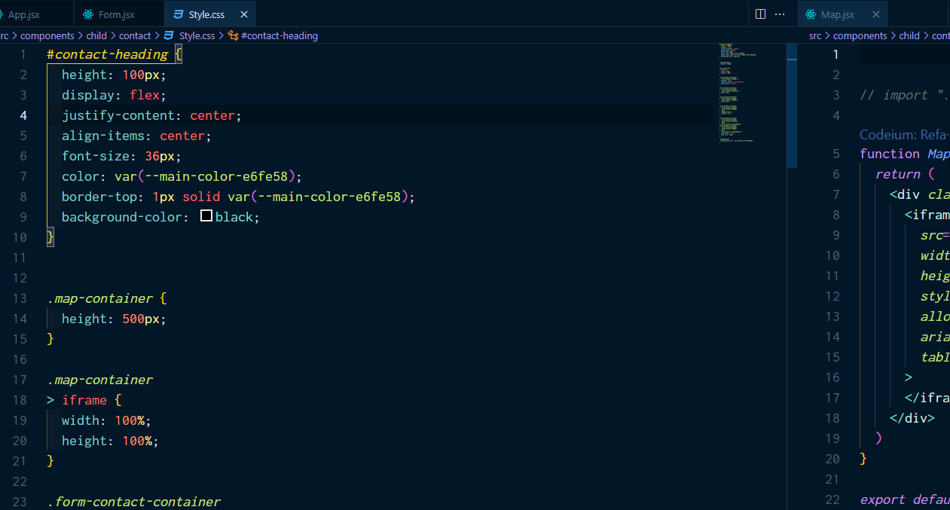

***9. Tos Page: Information about terms of use***

* ***Terms of Service***

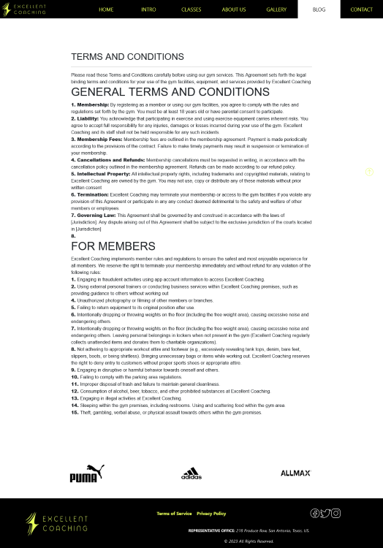

***Source:***

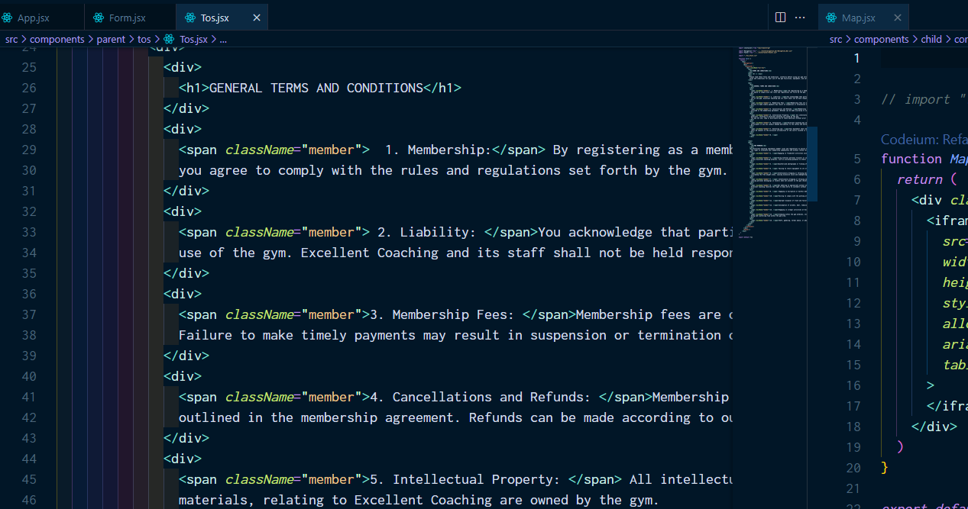

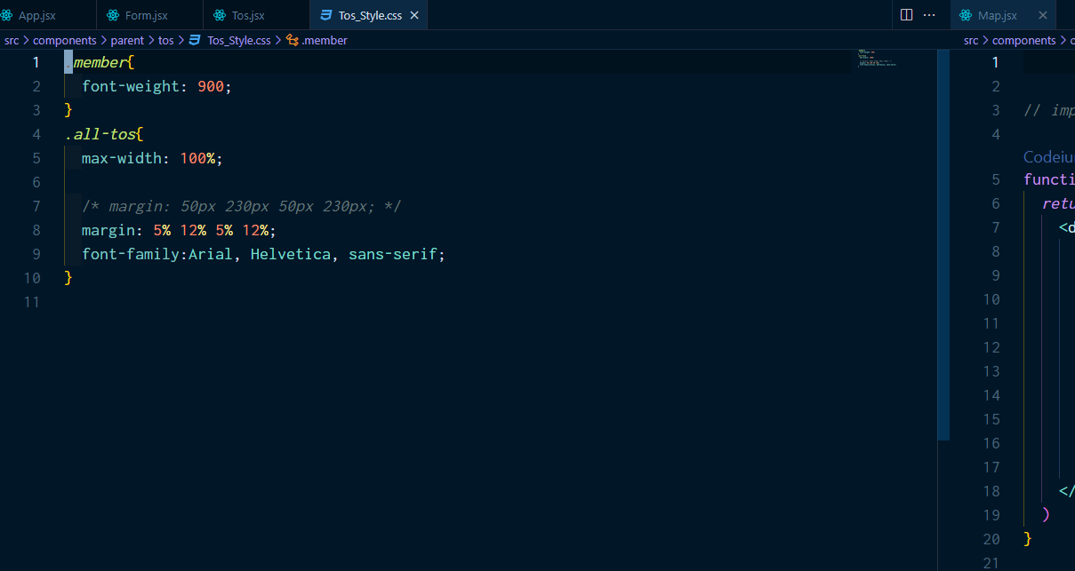

***10. Privacy Page: Our personal data use policy***

* ***Privacy Policy***

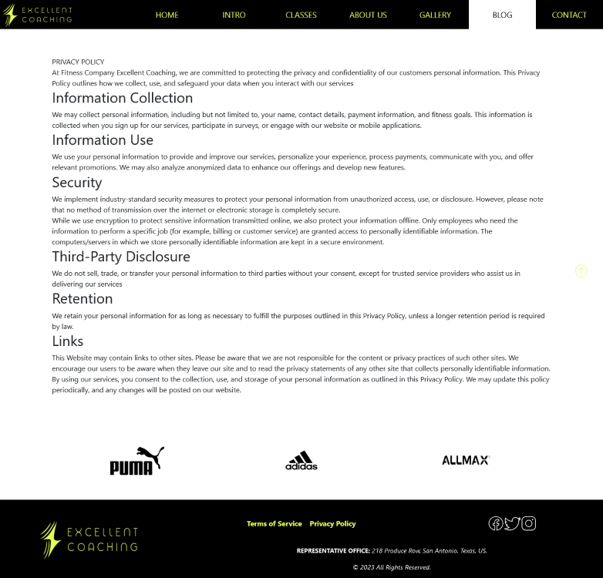

***Source:***

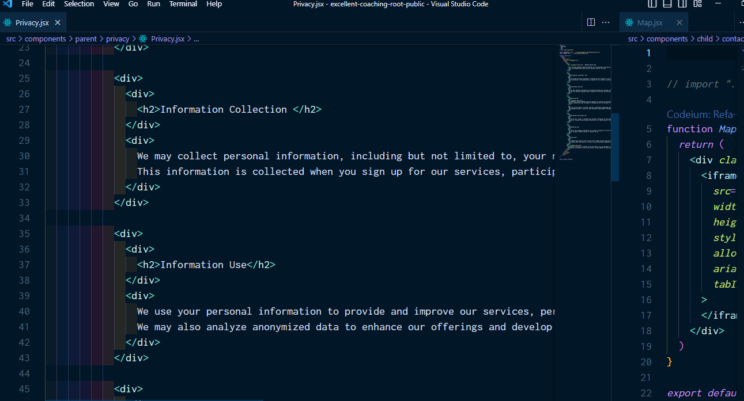

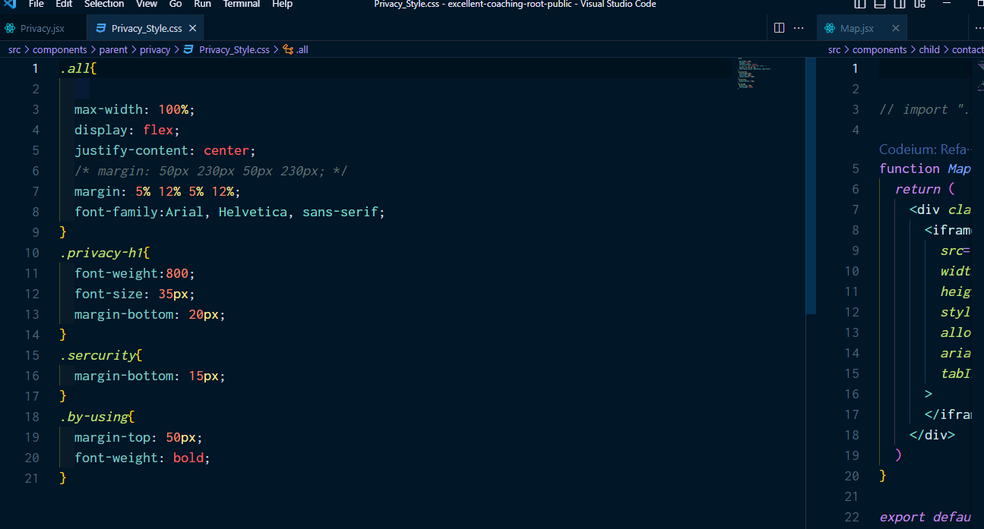

***TASK SHEET REVIEW 3***

|  |  |  |  |  |  |  |  |
| --- | --- | --- | --- | --- | --- | --- | --- |
| **Project Ref. No.:**  **eP/Advertisement Portal Management System/01** | | **Project Title:** | **Activity Plan Prepared By:** | **Date of Preparation of Activity Plan:** | | | |
| **Sr.**  **No.** | **Task** | **Actual**  **Start Date** | **Actual Days** | **Team**  **Mate Names** | **Status** |
| 1 | Completed main pages:  Home, Intro, Class, About and Contact | Excellent  Coaching | Giang | 05-Oct-2023 | 1 | Giang, Hải, Bằng | Completed |
| 2 | Completed subpages:  Course, Gallery, Blog, Tos, Privacy | 05-Oct-2023 | 1 | Giang, Hải, Bằng | Completed |
| 3 | Fully set up the router | 05-Oct-2023 | 1 | Giang, Hải, Bằng | Completed |
| 4 | Completed JSON data layout for pages | 05-Oct-2023 | 1 | Giang, Hải, Bằng | Completed |
| 5 | Successfully imported google maps | 05-Oct-2023 | 1 | Giang, Hải, Bằng | Completed |
| 6 | Complete file download feature | 05-Oct-2023 | 1 | Giang, Hải, Bằng | Completed |
| 7 | Testing |  |  | 05-Oct-2023 | 1 | Giang, Hải, Bằng | Completed |
| 8 | Debug |  |  | 05-Oct-2023 | 1 | Giang, Hải, Bằng | Completed |

|  |  |
| --- | --- |
| **Date: 05 – Oct – 2023** | |
| Signature of Instructor:  **Mr. Nguyen Phat Tai** | Signature of Team Leader:  **Ms.Tran Hương Giang** |